Assignment 1: Part 1 - Hosting a static web page using S3

For this assignment, we need to host a static web page using the S3 bucket. Here are the following steps:

1. First, we need to create a bucket with a unique bucket name.

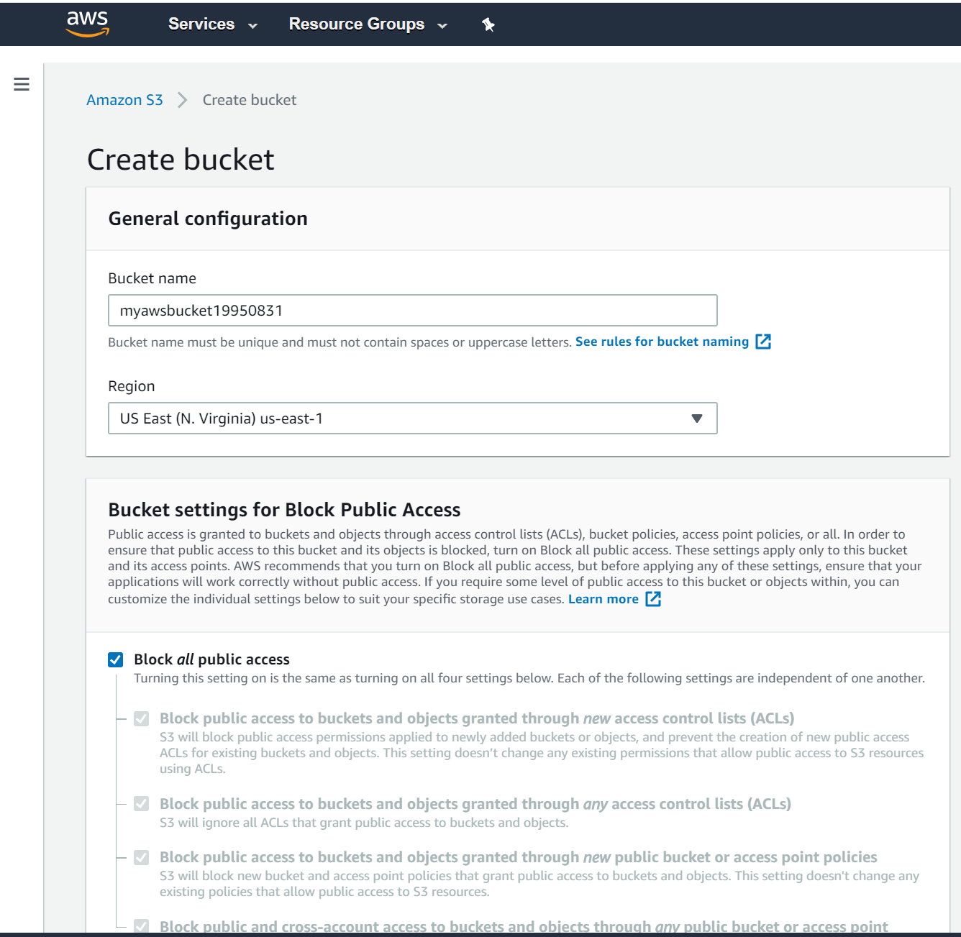

1. Since we need to host a static weg page, we need the index.html and error.html file in the bucket. I had already created them before. So, I uploaded it on the S3 bucket. 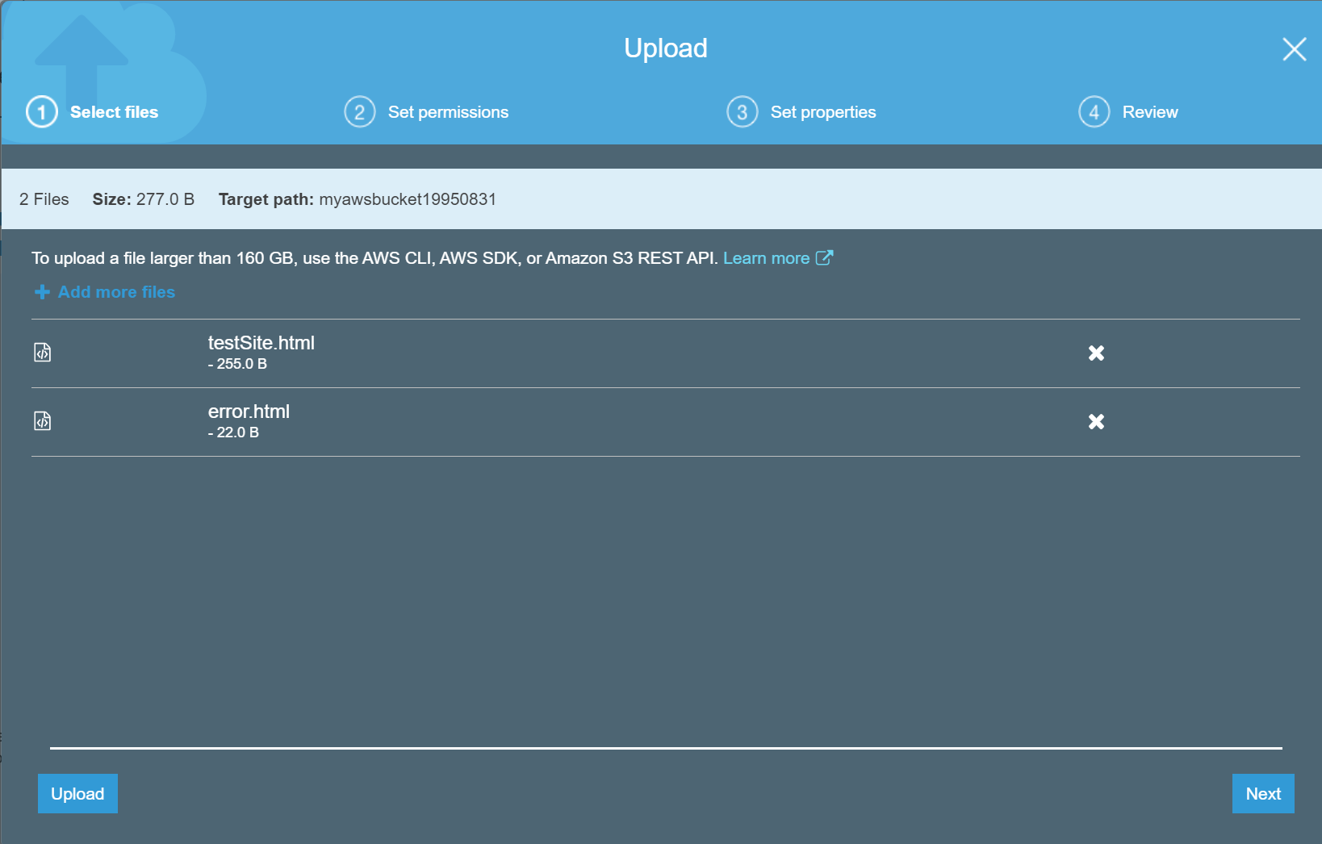
2. Next, I am going to change the permissions for public access.

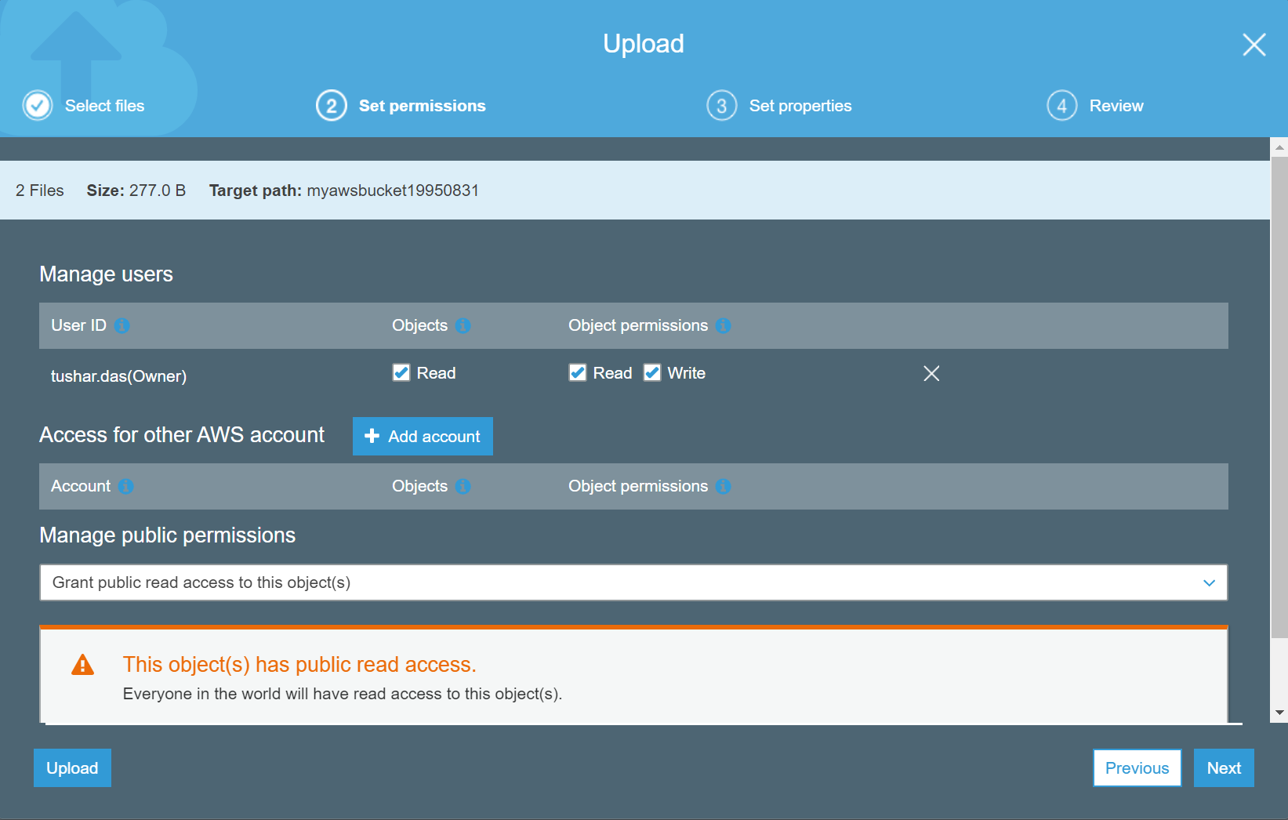

1. The files have been uploaded in the bucket as shown below.

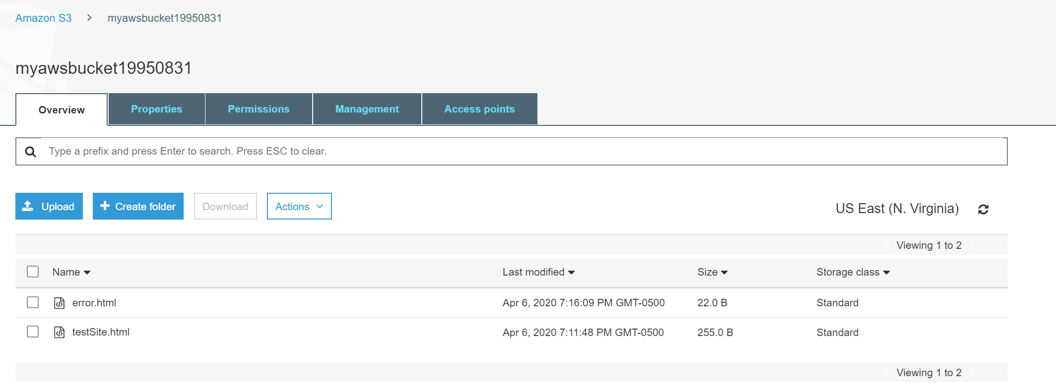

1. Next, we must go to properties and select the static website hosting option. Here, we need the index.html and error.html documents which we have already downloaded into our S3 bucket.

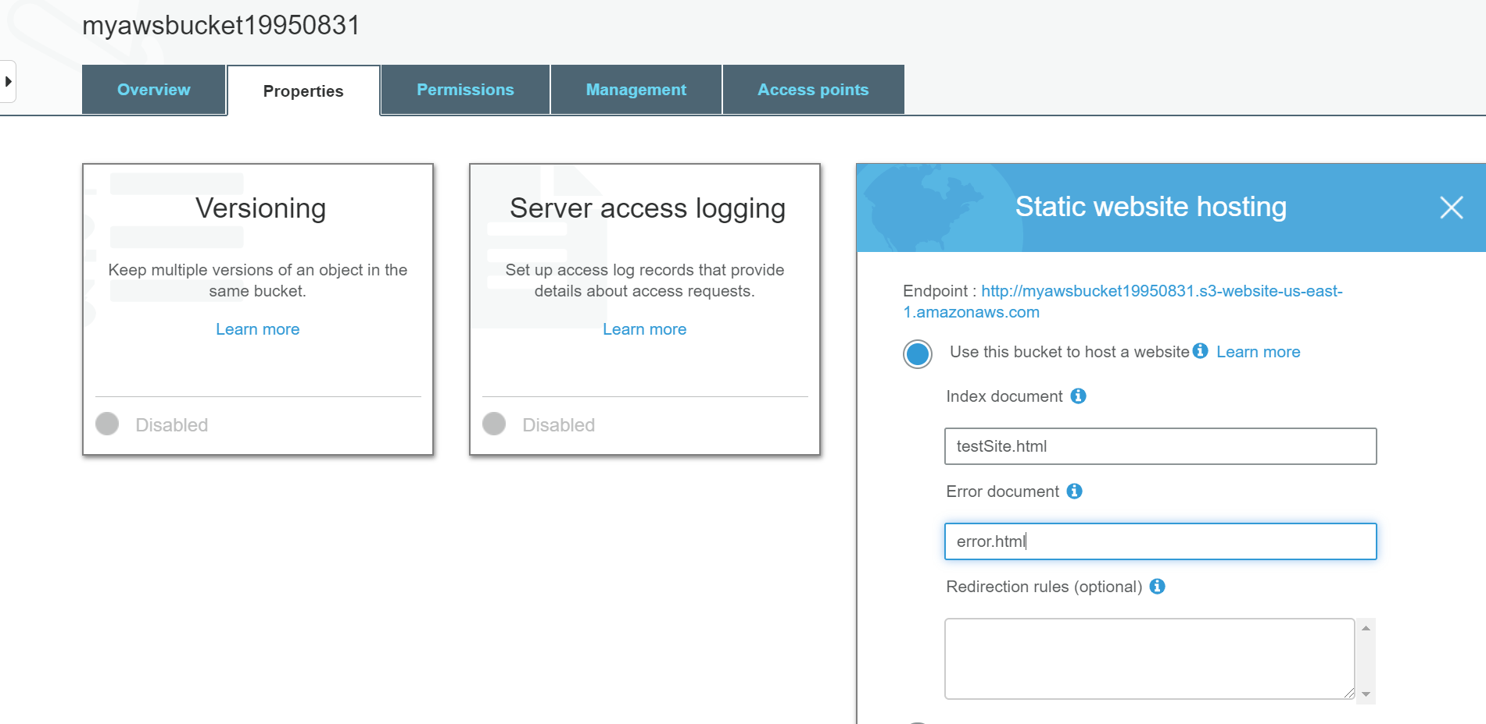

1. Finally, we use the endpoint URL to see our static website being hosted.

